

Directions: Fully simplify the following rational expressions.



1. ___________________________________



1. _______________________________________



1. _______________________________________

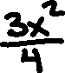

1. ________________________________________



1. ____________________________________

